# Task 3 — Website implementation

Following the design created in Task 2, use code to create the

pages of the website. Evidence required:

* HTML code used to produce each page of the website
* CSS code used to style the website
* Screenshots showing the layout of each page of the website matching the design.

**Index**

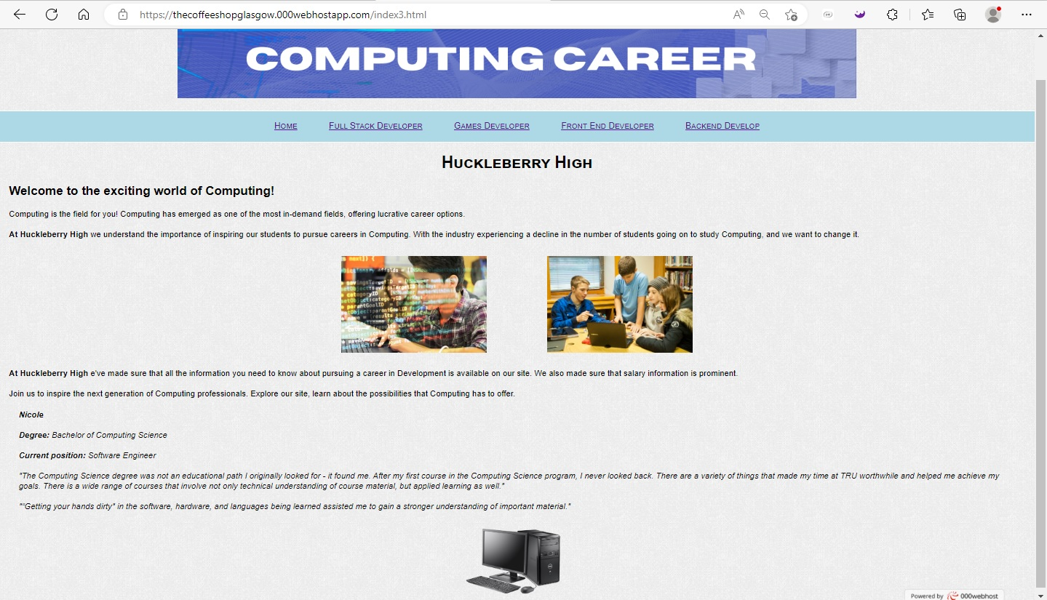

<!DOCTYPE html>

<html lang="en">

<head>

<title>Huckleberry High</title>

<link href="../CSS/Styles.css" rel="stylesheet">

<meta charset="UTF-8">

</head>

<body>

<div id="header">

<img class="ban" src="../IMG/Banner1.png" alt="Banner with logo.">

</div>

<nav>

<a href="index.html">Home</a>

<a href="fullstack.html">Full Stack Developer</a>

<a href="games.html">Games Developer</a>

<a href="frontend.html">Front End Developer</a>

<a href="backend.html">Backend Develop</a>

</nav>

<h1>Huckleberry High</h1>

<h2>Welcome to the exciting world of Computing! </h2>

<p>Computing is the field for you! Computing has emerged as one of the most in-demand fields, offering lucrative career options.</p>

<p><span class="bol">At Huckleberry High </span>we understand the importance of inspiring our students to pursue careers in Computing. With the industry experiencing a decline in the number of students going on to study Computing, and we want to change it. </p>

<table>

<tr>

<td> <img class="image" src="../IMG/web_dev_10.jpg" alt="picture of sudents in class 1"> </td>

<td> <img class="image" src="../IMG/web_dev_8.jpg" alt="picture of sudents in class 2"> </td>

</tr>

</table>

<p><span class="bol">At Huckleberry High</span> e've made sure that all the information you need to know about pursuing a career in Development is available on our site. We also made sure that salary information is prominent.</p>

<p>Join us to inspire the next generation of Computing professionals. Explore our site, learn about the possibilities that Computing has to offer.</p>

<blockquote class="ita">

<span class="bol">Nicole </span>

<p></p>

<span class="bol">Degree:</span> Bachelor of Computing Science

<p></p>

<span class="bol">Current position:</span> Software Engineer

<p></p>

"The Computing Science degree was not an educational path I originally looked for - it found me. After my first course in the Computing Science program, I never looked back.

There are a variety of things that made my time at TRU worthwhile and helped me achieve my goals. There is a wide range of courses that involve not only technical understanding of course material, but applied learning as well."

<p></p>

"“Getting your hands dirty" in the software, hardware, and languages being learned assisted me to gain a stronger understanding of important material."

</blockquote>

<img class="image2" src="../IMg/PC.png" alt="Just a PC">

</body>

</html>

**Full Stack Developers** 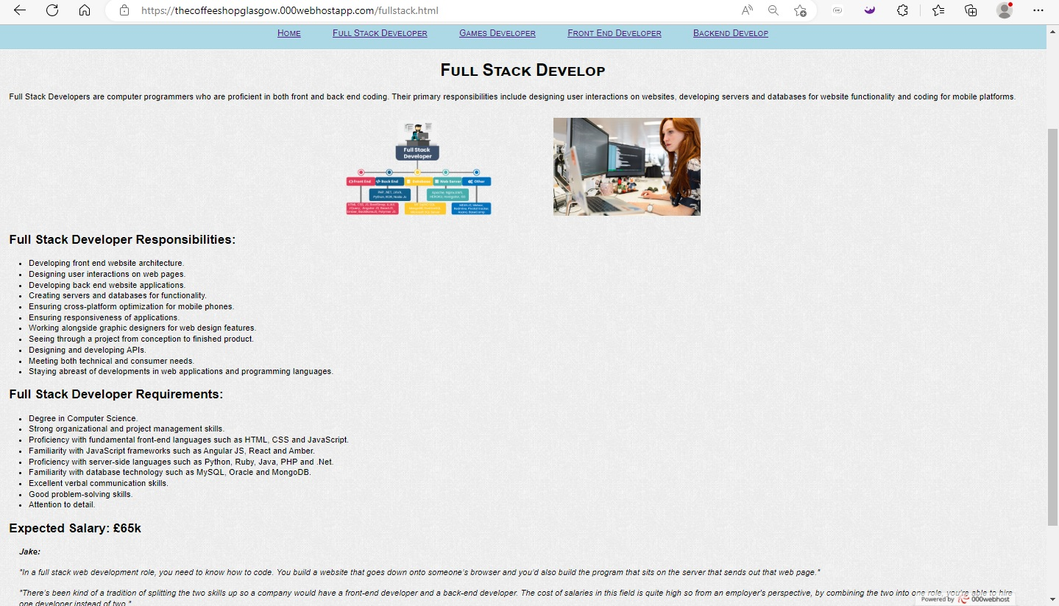

<!DOCTYPE html>

<html lang="en">

<head>

<title>Full Stack Developers</title>

<link href="../CSS/Styles.css" rel="stylesheet">

<meta charset="UTF-8">

</head>

<body>

<div id="header">

<img class="ban" src="../IMG/Banner1.png" alt="Banner with logo.">

</div>

<nav>

<a href="index.html">Home</a>

<a href="fullstack.html">Full Stack Developer</a>

<a href="games.html">Games Developer</a>

<a href="frontend.html">Front End Developer</a>

<a href="backend.html">Backend Develop</a>

</nav>

<h1>Full Stack Develop</h1>

<p>Full Stack Developers are computer programmers who are proficient in both front and back end coding. Their primary responsibilities include designing user interactions on websites, developing servers and databases for website functionality and coding for mobile platforms.</p>

<table>

<tr>

<td> <img class="image" src="../IMG/full_stack.png" alt="Girl at work"> </td>

<td> <img class="image" src="../IMG/web_dev_4.jpg" alt="Girl at work"> </td>

</tr>

</table>

<h2>Full Stack Developer Responsibilities:</h2>

<ul>

<li>Developing front end website architecture.</li>

<li>Designing user interactions on web pages.</li>

<li>Developing back end website applications.</li>

<li>Creating servers and databases for functionality.</li>

<li>Ensuring cross-platform optimization for mobile phones.</li>

<li>Ensuring responsiveness of applications.</li>

<li>Working alongside graphic designers for web design features.</li>

<li>Seeing through a project from conception to finished product.</li>

<li>Designing and developing APIs.</li>

<li>Meeting both technical and consumer needs.</li>

<li>Staying abreast of developments in web applications and programming languages.</li>

</ul>

<h2>Full Stack Developer Requirements:</h2>

<ul>

<li>Degree in Computer Science.</li>

<li>Strong organizational and project management skills.</li>

<li>Proficiency with fundamental front-end languages such as HTML, CSS and JavaScript.</li>

<li>Familiarity with JavaScript frameworks such as Angular JS, React and Amber.</li>

<li>Proficiency with server-side languages such as Python, Ruby, Java, PHP and .Net.</li>

<li>Familiarity with database technology such as MySQL, Oracle and MongoDB.</li>

<li>Excellent verbal communication skills.</li>

<li>Good problem-solving skills.</li>

<li>Attention to detail.</li>

</ul>

<p></p>

<h2>Expected Salary: £65k</h2>

<blockquote class="ita"><span class="bol">Jake:</span>

<p></p>

"In a full stack web development role, you need to know how to code. You build a website that goes down onto someone’s browser and you’d also build the program that sits on the server that sends out that web page."

<p></p>

"There’s been kind of a tradition of splitting the two skills up so a company would have a front-end developer and a back-end developer. The cost of salaries in this field is quite high so from an employer's perspective, by combining the two into one role, you’re able to hire one developer instead of two."

</blockquote>

<img class="image2" src="../IMg/PC.png" alt="Just a PC">

</body>

</html>

**Games Developer**

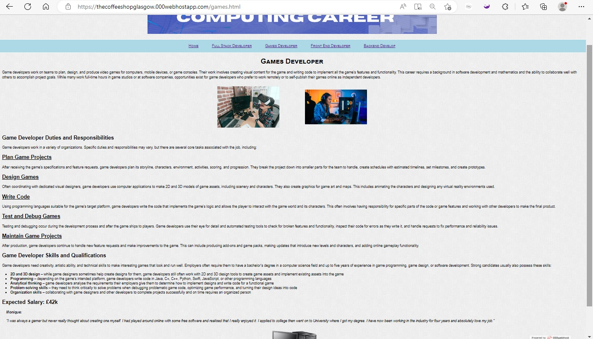

<!DOCTYPE html>

<html lang="en">

<head>

<title>Games Developer</title>

<link href="../CSS/Styles.css" rel="stylesheet">

<meta charset="UTF-8">

</head>

<body>

<div id="header">

<img class="ban" src="../IMG/Banner1.png" alt="Banner with logo.">

</div>

<nav>

<a href="index.html">Home</a>

<a href="fullstack.html">Full Stack Developer</a>

<a href="games.html">Games Developer</a>

<a href="frontend.html">Front End Developer</a>

<a href="backend.html">Backend Develop</a>

</nav>

<h1>Games Developer</h1>

<p>Game developers work on teams to plan, design, and produce video games for computers, mobile devices, or game consoles. Their work involves creating visual content for the game and writing code to implement all the game’s features and functionality. This career requires a background in software development and mathematics and the ability to collaborate well with others to accomplish project goals. While many work full-time hours in game studios or at software companies, opportunities exist for game developers who prefer to work remotely or to self-publish their games online as independent developers.</p>

<table>

<tr>

<td> <img class="image" src="../IMG/game_dev.jpg" alt="girl in VR helm"> </td>

<td> <img class="image" src="../IMG/videogirl.jpg" alt="girl develop"> </td>

</tr>

</table>

<h2>Game Developer Duties and Responsibilities</h2>

<p>Game developers work in a variety of organizations. Specific duties and responsibilities may vary, but there are several core tasks associated with the job, including:</p>

<h2><u>Plan Game Projects</u></h2>

<p>After receiving the game’s specifications and feature requests, game developers plan its storyline, characters, environment, activities, scoring, and progression. They break the project down into smaller parts for the team to handle, create schedules with estimated timelines, set milestones, and create prototypes.</p>

<h2><u>Design Games</u></h2>

<p>Often coordinating with dedicated visual designers, game developers use computer applications to make 2D and 3D models of game assets, including scenery and characters. They also create graphics for game art and maps. This includes animating the characters and designing any virtual reality environments used.</p>

<h2><u>Write Code</u></h2>

<p>Using programming languages suitable for the game’s target platform, game developers write the code that implements the game’s logic and allows the player to interact with the game world and its characters. This often involves having responsibility for specific parts of the code or game features and working with other developers to make the final product.</p>

<h2><u>Test and Debug Games</u></h2>

<p>Testing and debugging occur during the development process and after the game ships to players. Game developers use their eye for detail and automated testing tools to check for broken features and functionality, inspect their code for errors as they write it, and handle requests to fix performance and reliability issues.</p>

<h2><u>Maintain Game Projects</u></h2>

<p>After production, game developers continue to handle new feature requests and make improvements to the game. This can include producing add-ons and game packs, making updates that introduce new levels and characters, and adding online gameplay functionality.</p>

<h2>Game Developer Skills and Qualifications</h2>

<p>Game developers need creativity, artistic ability, and technical skills to make interesting games that look and run well. Employers often require them to have a bachelor’s degree in a computer science field and up to five years of experience in game programming, game design, or software development. Strong candidates usually also possess these skills:</p>

<ul>

<li><span class="bol">2D and 3D design </span> – while game designers sometimes help create designs for them, game developers still often work with 2D and 3D design tools to create game assets and implement existing assets into the game</li>

<li><span class="bol">Programming </span> – depending on the game’s intended platform, game developers write code in Java, C+, C++, Python, Swift, JavaScript, or other programming languages</li>

<li><span class="bol">Analytical thinking </span> – game developers analyse the requirements their employers give them to determine how to implement designs and write code for a functional game</li>

<li><span class="bol">Problem-solving skills </span> – they need to think critically to solve problems when debugging problematic game code, optimizing game performance, and turning their design ideas into code</li>

<li><span class="bol">Organization skills </span> – collaborating with game designers and other developers to complete projects successfully and on time requires an organized person</li>

</ul>

<h2>Expected Salary: £42k</h2>

<blockquote class="ita">

<span class="bol">Monique:</span>

<p></p>

"I was always a gamer but never really thought about creating one myself. I had played around online with some free software and realised that I really enjoyed it. I applied to college then went on to University where I got my degree. I have now been working in the industry for four years and absolutely love my job."

</blockquote>

<img class="image2" src="../IMg/PC.png" alt="Just a PC">

</body>

</html>

**Front End Developer**

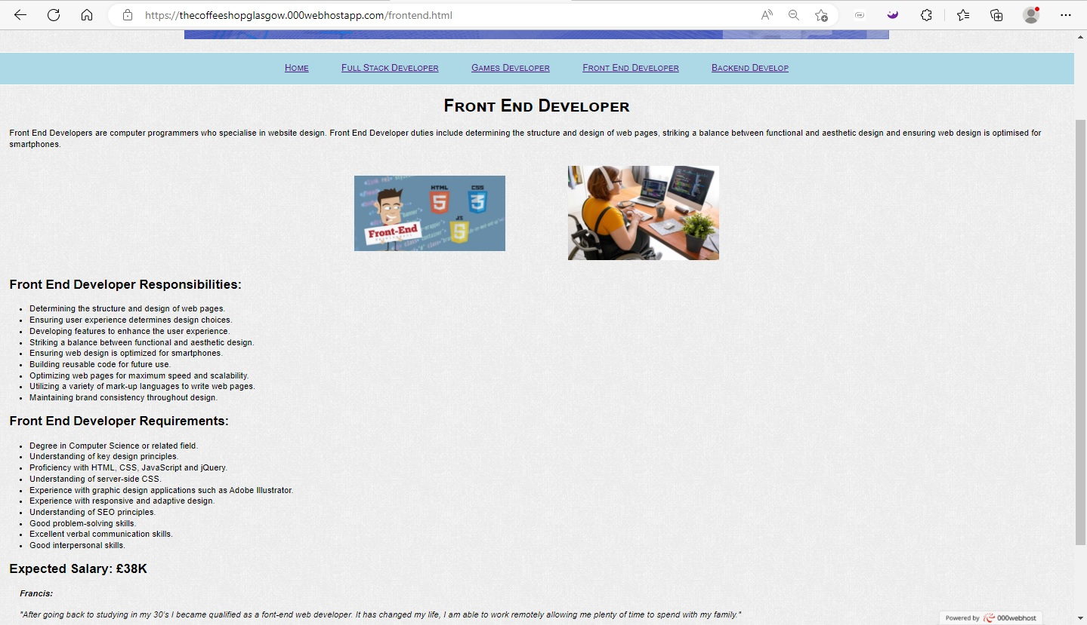

<!DOCTYPE html>

<html lang="en">

<head>

<title>Front End Developer</title>

<link href="../CSS/Styles.css" rel="stylesheet">

<meta charset="UTF-8">

</head>

<body>

<div id="header">

<img class="ban" src="../IMG/Banner1.png" alt="Banner with logo.">

</div>

<nav>

<a href="index.html">Home</a>

<a href="fullstack.html">Full Stack Developer</a>

<a href="games.html">Games Developer</a>

<a href="frontend.html">Front End Developer</a>

<a href="backend.html">Backend Develop</a>

</nav>

<h1>Front End Developer</h1>

<p>Front End Developers are computer programmers who specialise in website design. Front End Developer duties include determining the structure and design of web pages, striking a balance between functional and aesthetic design and ensuring web design is optimised for smartphones.</p>

<table>

<tr>

<td> <img class="image" src="../IMG/front_end.jpg" alt="Front-end"> </td>

<td> <img class="image" src="../IMG/web_dev_6.jpg" alt="Girl at work"> </td>

</tr>

</table>

<h2>Front End Developer Responsibilities:</h2>

<ul>

<li>Determining the structure and design of web pages.</li>

<li>Ensuring user experience determines design choices.</li>

<li>Developing features to enhance the user experience.</li>

<li>Striking a balance between functional and aesthetic design.</li>

<li>Ensuring web design is optimized for smartphones.</li>

<li>Building reusable code for future use.</li>

<li>Optimizing web pages for maximum speed and scalability.</li>

<li>Utilizing a variety of mark-up languages to write web pages.</li>

<li>Maintaining brand consistency throughout design.</li>

</ul>

<h2>Front End Developer Requirements:</h2>

<ul>

<li>Degree in Computer Science or related field.</li>

<li>Understanding of key design principles.</li>

<li>Proficiency with HTML, CSS, JavaScript and jQuery.</li>

<li>Understanding of server-side CSS.</li>

<li>Experience with graphic design applications such as Adobe Illustrator.</li>

<li>Experience with responsive and adaptive design.</li>

<li>Understanding of SEO principles.</li>

<li>Good problem-solving skills.</li>

<li>Excellent verbal communication skills.</li>

<li>Good interpersonal skills.</li>

</ul>

<p></p>

<h2>Expected Salary: £38K</h2>

<blockquote class="ita">

<span class="bol">Francis:</span>

<p></p>

"After going back to studying in my 30’s I became qualified as a font-end web developer. It has changed my life, I am able to work remotely allowing me plenty of time to spend with my family."

</blockquote>

<img class="image2" src="../IMg/PC.png" alt="Just a PC">

</body>

</html>

**Backend Develop**

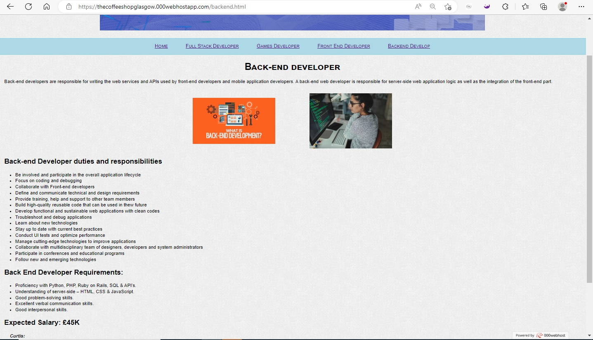

<!DOCTYPE html>

<html lang="en">

<head>

<title>Back-end developer</title>

<link href="../CSS/Styles.css" rel="stylesheet">

<meta charset="UTF-8">

</head>

<body>

<div id="header">

<img class="ban" src="../IMG/Banner1.png" alt="Banner with logo.">

</div>

<nav>

<a href="index.html">Home</a>

<a href="fullstack.html">Full Stack Developer</a>

<a href="games.html">Games Developer</a>

<a href="frontend.html">Front End Developer</a>

<a href="backend.html">Backend Develop</a>

</nav>

<h1>Back-end developer</h1>

<p> Back-end developers are responsible for writing the web services and APIs used by front-end developers and mobile application developers.

A back-end web developer is responsible for server-side web application logic as well as the integration of the front-end part.

</p>

<table>

<tr>

<td> <img class="image" src="../IMG/back_end.png" alt="back-end"> </td>

<td> <img class="image" src="../IMG/web_dev_3.jpg" alt="Girl at work"> </td>

</tr>

</table>

<h2>Back-end Developer duties and responsibilities</h2>

<ul>

<li> Be involved and participate in the overall application lifecycle</li>

<li>Focus on coding and debugging</li>

<li>Collaborate with Front-end developers</li>

<li>Define and communicate technical and design requirements</li>

<li>Provide training, help and support to other team members</li>

<li>Build high-quality reusable code that can be used in thew future</li>

<li>Develop functional and sustainable web applications with clean codes</li>

<li>Troubleshoot and debug applications</li>

<li>Learn about new technologies</li>

<li>Stay up to date with current best practices</li>

<li>Conduct UI tests and optimize performance</li>

<li>Manage cutting-edge technologies to improve applications</li>

<li>Collaborate with multidisciplinary team of designers, developers and system administrators</li>

<li>Participate in conferences and educational programs</li>

<li>Follow new and emerging technologies</li>

</ul>

<h2>Back End Developer Requirements:</h2>

<ul>

<li>Proficiency with Python, PHP, Ruby on Rails, SQL & API’s.</li>

<li>Understanding of server-side – HTML, CSS & JavaScript.</li>

<li>Good problem-solving skills.</li>

<li>Excellent verbal communication skills.</li>

<li>Good interpersonal skills.</li>

</ul>

<h2>Expected Salary: £45K</h2>

<blockquote class="ita"><span class="bol">Curtis:</span>

<p></p>

"I was always interested in computing in school so decided to go to University to further my knowledge. I didn’t have the best interpersonal skills and felt uncomfortable speaking in front of people. I really enjoy the challenge of developing complex code. Working as a back-end developer I don’t need to speak with clients as often."

</blockquote>

<img class="image2" src="../IMg/PC.png" alt="Just a PC">

</body>

</html>

**CSS**

body {

background-image: url(../IMG/backgr.gif);

margin: 0px;

font-family: Arial, Helvetica;

line-height: 1.3;

font-size: 17px;

}

h1 {

text-align: center;

font-variant: small-caps;

margin: 20px;

}

h2 {

margin-left: 20px;

margin-right: 20px;

margin: 20px;

}

.ita {

font-style: italic;

}

.bol {

font-weight: 700;

}

#header {

margin: 0 auto;

padding: 0 px;

text-align: center;

margin-bottom: 20px;

}

#header img {

width: 90%;

max-width: 1400px;

}

.image {

width: 70%;

min-width: 300px;

max-width: 400px;

padding: 10px;

margin: auto;

display: block;

}

.image2 {

width: 10%;

max-width: 300px;

padding: 10px;

margin: auto;

display: block;

}

table {

margin: 0 auto;

}

.bol {

font-weight: bold;

}

nav {

font-variant: small-caps;

text-align: center;

font-family: sans-serif;

font-size: 18px;

background-color: lightblue;

padding-top: 20px;

padding-bottom: 20px;

border-bottom: 2px solid #ffffff;

border-top: 2px solid #ffffff;

}

ul {

font-size: 17px;

margin: 20px;

}

a {

padding: 15px;

margin: 15px;

}

p {

margin-left: 20px;

margin-right: 20px;

margin: 20px;

}